# Comparison of PDE pricer results against market prices

We have conducted a comparison of our PDE pricer results against market prices we obtained from [TODO ADD PRICES SOURCE] together with volatilities. We chose GOOGL security as a liquid one, having no dividends. We were using prices as of 21-01-2020, as this date had most data for GOOGL. We have conducted tests for calls and puts separately, as implied volatilities for calls and puts with same strikes were different in the data we obtained.

## Methodology

Separately for calls and puts we were doing the following:

We used spot (1482.25) and implied volatilities from market data to build a strike-based volatility surface. Then for every strike and expiry date pair we priced an option with same settings of PDE grid: a total of 366 uniformly distributed time points across a total of 100 uniformly distributed spot points, ranging from spot * 0.5 to spot * 2. We used our yield curve for as of date 21-01-2020, built as described in [TODO ADD REFERENCE] Interest rates model section.

For every option we calculated its price (Present Value, PV) and 2 benchmarks against the source data bid-offer range: “Diff” – the absolute difference against mid market price (an average of bid and ask), and a “Bad Diff” – the amount (in dollars) showing by how much our PV is less than bid (negative) or is greater than ask price (positive). If our PV was inside market bid-ask range, Bad Diff was set to 0.

This calculation was conducted using python code in reports/pde_pv_diffs.py. The order of iteration was in line with source data: the “outer loop” goes over increasing expiry dates, and within every expiry date the “inner loop” goes over strikes, so first result is strike[0], expiry[0], 2nd is strike[1] expiry[0], etc.

## Results for puts

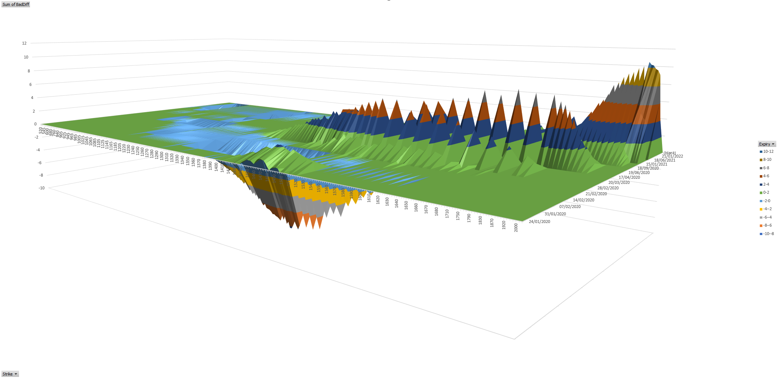

Fig. [TODO Figure PUTS1].

Fig. [TODO PUTS1] shows Bad Diff (in dollars) values for put options we calculated, as an Expiry Date vs Strike pivot table. Notably a high proportion of values have Bad Diff equal to 0, which means mostly our PDE pricer gives results consistent with the actual market.

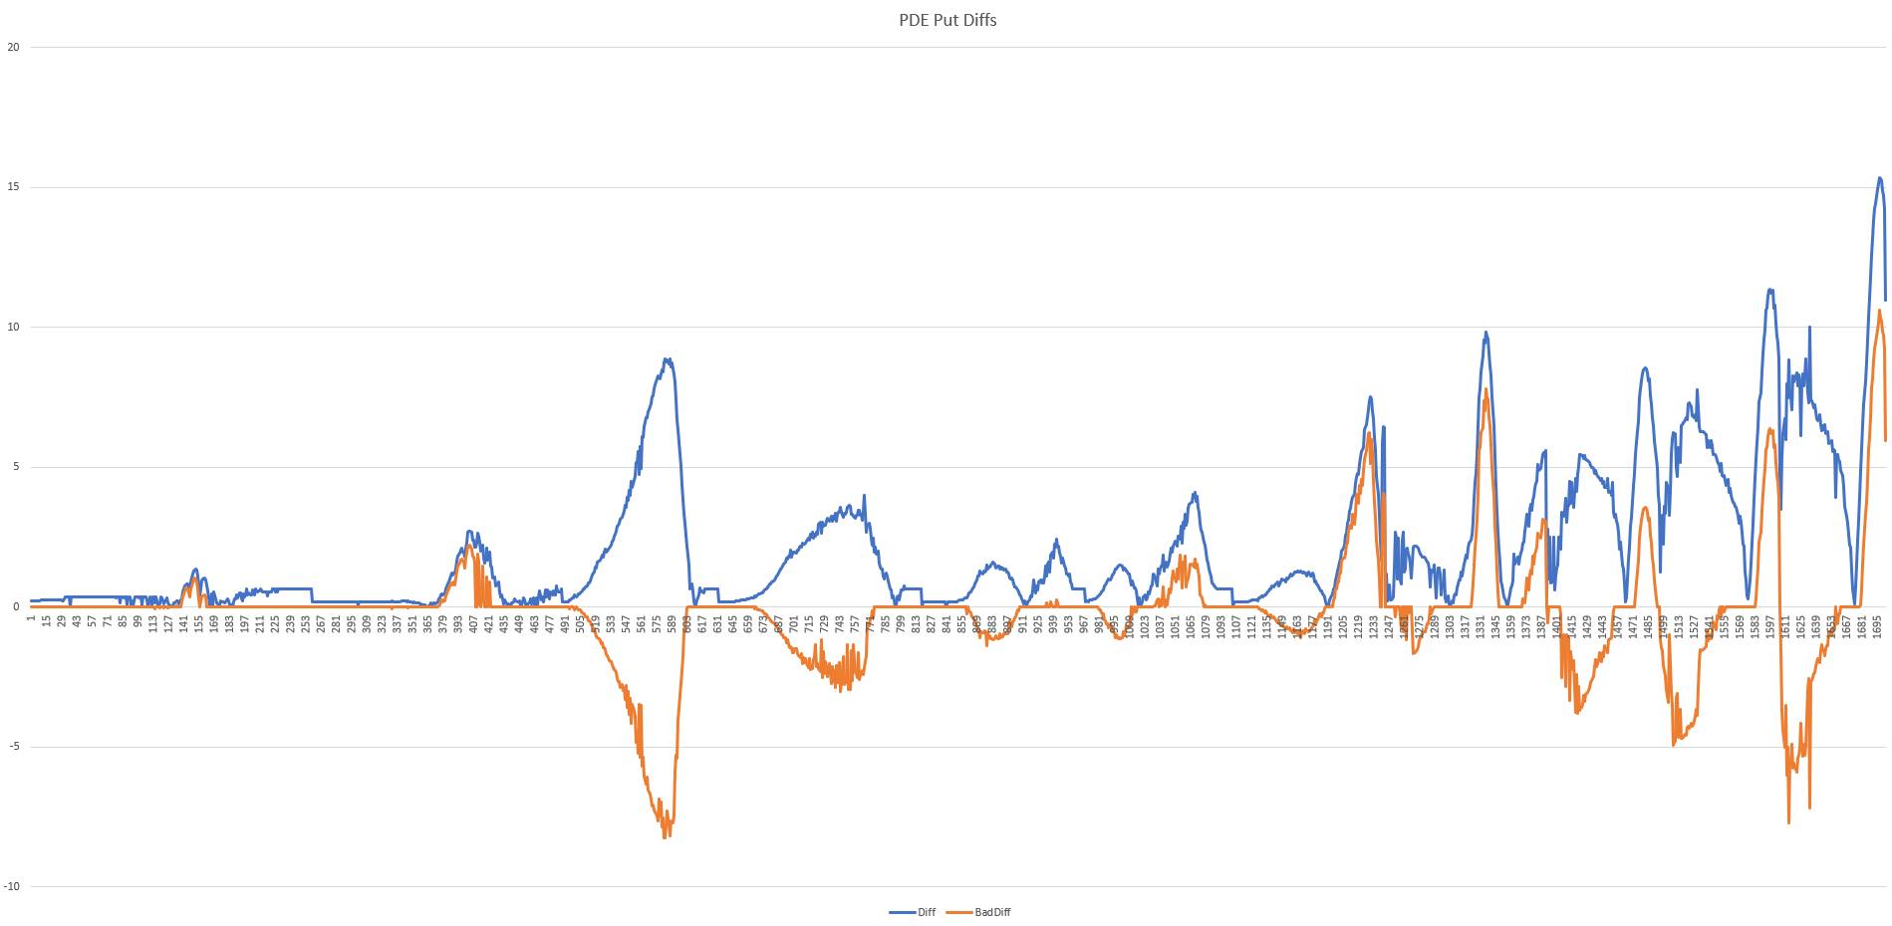

Fig. [TODO Figure PUTS2].

Fig. [TODO PUTS2] shows both Diff and Bad Diff values for puts, in the order of the source data i.e. leftmost part shows increasing strikes’ results for the minimal expiry date (24-01-2020), followed by increasing strikes’ results for the next expiry date (31-01-2020) and so on.

Results for put options can be found in [TODO: Appendix A].

## Results for calls

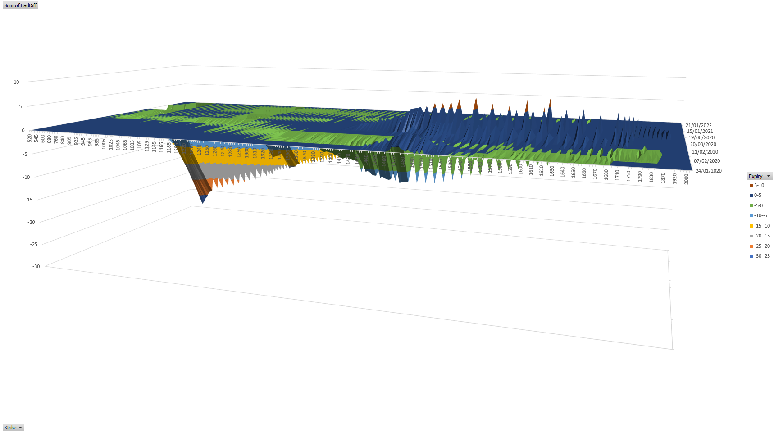

Fig. [TODO Figure CALLS1].

Fig. [TODO CALLS1] shows Bad Diff (in dollars) values for call options we calculated, as an Expiry Date vs Strike pivot table. Here we can also observe a high proportion of values have Bad Diff equal to 0.

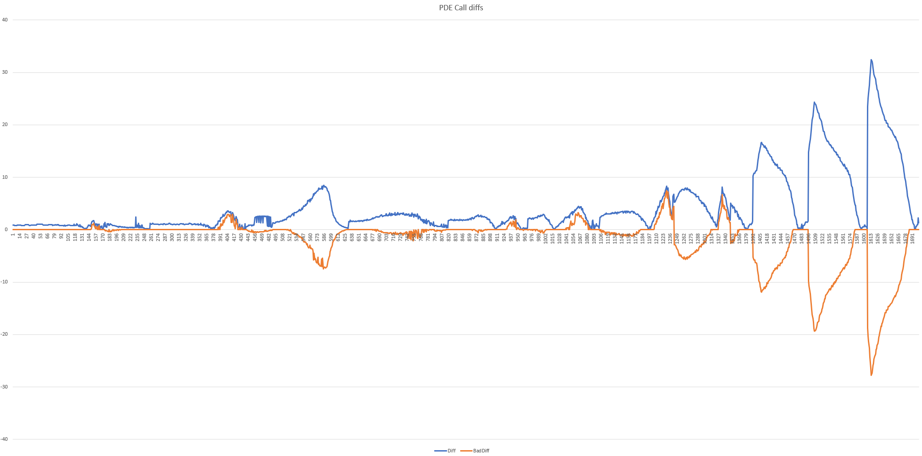

Fig. [TODO Figure CALLS2].

Fig. [TODO CALLS2] shows both Diff and Bad Diff values for calls, in the order of the source data.

Results for call options can be found in [TODO: Appendix B].

## Discussion

Despite we can see our PDE pricer results are not ideal, we can argue this is still a good result for a research0grade pricer: 879 out of 1703 put prices (52%) and 778 out of 1703 call prices (46%) have a bad diff of 0. Of course, this wouldn’t be sufficient for a real-life pricer, but the main purpose of this work was to show what has to be considered when implementing option pricers, so our main goal with PDE pricer was mostly to show its results make sense.

For puts we see most positive bad diffs are seen for high strikes and big expiry dates. Indeed, we would not expect to see any diffs for low strikes, as puts for low strikes are out of the money and hence their absolute prices are close to 0. Interestingly, we see most negative diffs around at the money strikes (1482.25 is market spot value) for 02-02-2020 and 14-02-2020. We also see some positive bad diffs for strikes close to ATM for 28-02-2020, 30-02-2020 and 17-04-2020. All these close-to-ATM strikes diffs may be an indication of insufficient grid density and/or pronounced effect of imperfect volatility surface interpolation around ATM strike where volatility surface has biggest curvature for most expiry dates.

For calls most severe diffs are also seen in the in-the-money region (low strikes) for bigger expiry dates, with some additional diffs also observed around ATM.

The differences we see are pretty well clustered, which is an indication of their non-random nature. As we said when we described our implementation, there are quite a few simplified approaches used, especially around interpolation of both rates and volatilities. Given almost half of our results are within the bid-offer range, and that call prices match Black-Scholes European prices well for constant volatilities, as seen in tests, we can conclude our PDE pricer implementation is correct with a very high degree of confidence.